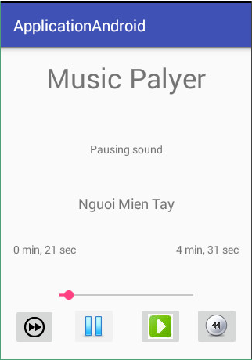

<http://giasutinhoc.vn/lap-trinh/phat-trien-app-android/media-player-trong-android-bai-4-2/>